**INSTALACION DE GENTOO:**

[**https://www.youtube.com/watch?v=FMfif9hGST4**](https://www.youtube.com/watch?v=FMfif9hGST4)

[**https://www.youtube.com/watch?v=Bv2V6fp3LG0&t=18s**](https://www.youtube.com/watch?v=Bv2V6fp3LG0&t=18s)

**(los mejores videos, sigues los pasos y a tomar por culo)**

Keymap: español 13

Cfdisk

Dos

Particiones:

New

500M – PRIMARY- BOOTABLE

22G(20)

25.5G(27.5)

2G

Write-yes

Quit

Formato a las particiones:

Mkfs.ext2 /dev/sda1

Mkfs.ext4 /dev/sda2

Mkfs.ext4 /dev/sda3

Mkswap /dev/sda4

Swapon /dev/sda4

Mount /dev/sda2 /mnt/gentoo

Mkdir /mnt/gentoo/home

Mkdir /mnt/gentoo/boot

Mount /dev/sda1 /mnt/gentoo/boot

Mount /dev/sda3 /mnt/gentoo/home

Cd /mnt/gentoo

Links <https://www.gentoo.org/downloads/mirrors>

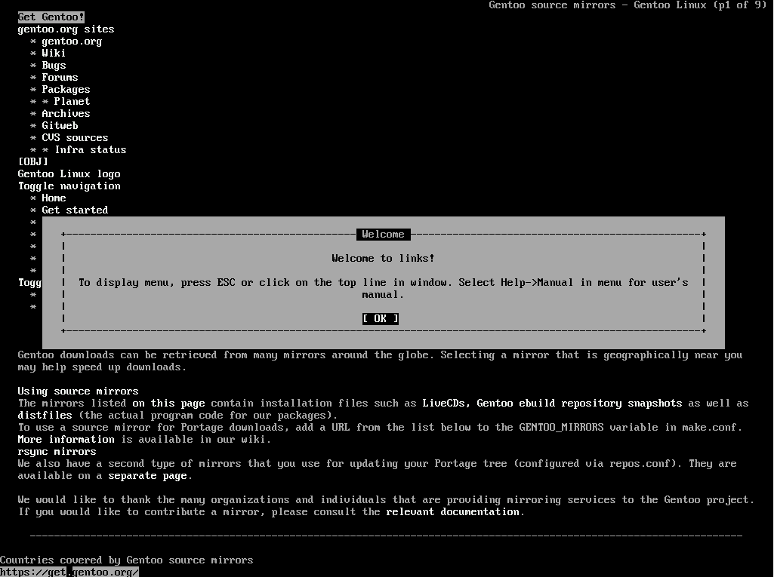

Downloads

Stage3 y hacia adelante y se instala

Exit

tar -Jxvf stage3 (tab) –xattrs –numeric-ow

nano -w /mnt/gentoo/etc/portage/make.conf

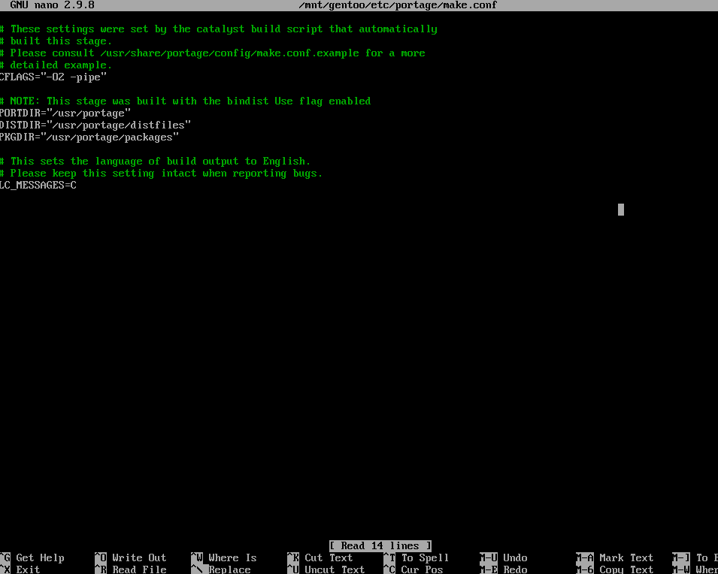

(se me olvidó una cosa)

ACCEPT_LICENCE=“*”

LINGUAS=“es es_ES”

L10N=“es es-ES”

Mirrorselect -i -o >> /mnt/gentoo/etc/portage/make.conf

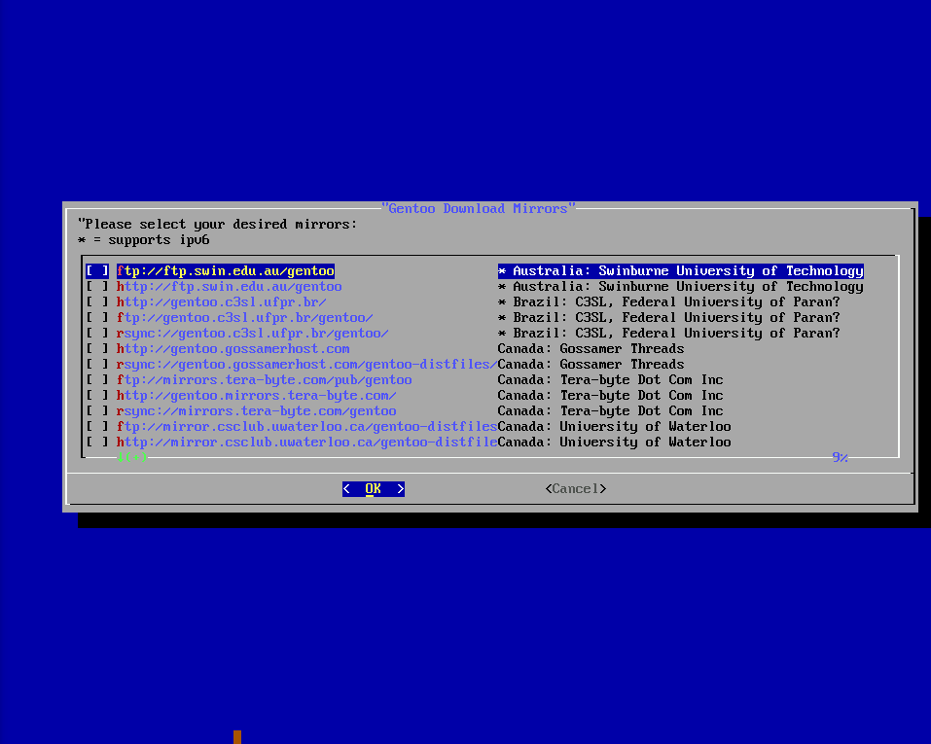

(mirar video) Portugal/Romania/Rusia

Mkdir /mnt/gentoo/etc/portage/repos.conf

Cp /mnt/gentoo/usr/share/portage/config/repos.conf /mnt/gentoo/etc/portage/repos.conf/gentoo.conf

cp -L /etc/resolv.conf /mnt/gentoo/etc/

Mount -t proc /proc /mnt/gentoo/proc

Mount –rbind /sys /mnt/gentoo/sys

Mount –make-rslave /mnt/gentoo/sys

Mount –rbind /dev /mnt/gentoo/dev

Mount –make-rslave /mnt/gentoo/dev

Chroot /mnt/gentoo /bin/bash

Source /etc/profile

Export PS1=”(chroot) $PS1”

Emerge-webrsync

Emerge –sync

Eselect (no hace falta)

Eselect profile set 16

Emerge –ask –update –deep –newuse @world

Ls /urs/share/zoneinfo

Echo “Europe/Madrid” > /etc/localtime

Emerge –config sys-libs/timezone-data

Echo “Europe/Madrid” > /etc/timezone

Emerge –config sys-libs/timezone-data

Nano -w /etc/locale.gen

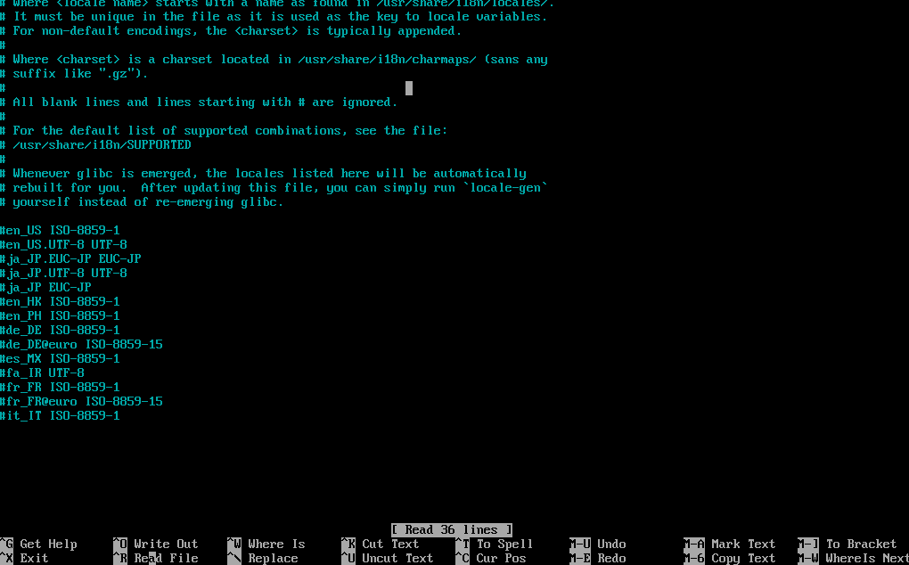

es_ES.UTF-8 UTF-8

locale-gen

eselect locale list

eselect locale set 3

emerge –ask gentoo-sources

ls -l /usr/src/Linux

nano -w /etc/fstab

/dev/sda1 /boot ext2 noatime 0 0

/dev/sda2 / ext4 noatime 0 1

/dev/sda3 /home ext4 noatime 0 2

/dev/sda4 none swap noatime 0 0

/dev/cdrom /mnt/cdrom auto noauto,user 0 0

Emerge –ask genkernel

Etc-update

1

Q

1

5

Q

5

Emerge genkernel (tarda)

Genkernel all (tarda)

Ifconfig

Nano -w /etc/conf.d/net (ponemos las dos ips con dhcp)

Confìg_enp0s3=”dhcp”

Config_enp0s8=”dhcp”

Passwd

123456

123456

Nano -w /etc/conf.d/keymaps

Keymap=”es”

Emerge –ask dhcpcd pciutils gentoolkit

Emerge –ask os-prober sys-boot/grub:2

Etc-update

1

Q

1

5

Q

5

Emerge os-prober sys-boot/grub:2

Grub-install /dev/sda

Grub-mkconfig -o /boot/grub/grub.cfg

Exit

Cd ..

Cd ..

Umount -l /mnt/gentoo/dev{/pts,/shm,}

Reboot

Quitar la iso

Root 123456

Crear usuario:

Useradd -m -G users,wheel,audio,video,usb,portage -s /bin/bash pedro

Passwd pedro

p123456

p123456

Escritorio:

Nano /etc/portage/make.conf

INPUT_DEVICES=”evdev synaptics”

VIDEO_CARDS=”nouveau”

Emerge –ask –verbose x11-base/xorg-drivers

Eselect news read

Emerge twm xterm

USE=”python” emerge xorg-x11

Locate vesa

emerge xf86-video-virtualbox

emerge xf86-video-vesa

Startx